UDC 33.330.13   
 **Biloskurskyi Ruslan**

Doctor of Economics, Associate Professor,

Dean of the Faculty of Economics

Yuriy Fedkovych Chernivtsi National University **Yevchuk Khrystyna-Iryna**

PhD graduate student of the Department of Economic Theory,

Management and Administration

Yuri Fedkovych Chernivtsi National University

**Білоскурський Р.Р., Євчук Х.-І.В.**

Чернівецький національний університет імені Юрія Федьковича

**STRATEGIC ANALYSIS OF AGRICULTURAL WASTE MANAGEMENT MECHANISMS**

**СТРАТЕГІЧНИЙ АНАЛІЗ МЕХАНІЗМІВ УПРАВЛІННЯ ВІДХОДАМИ СІЛЬСЬКОГО ГОСПОДАРСТВА**

With the general development of the world economy, the total production of agricultural goods increased, and the total mass of waste from their production increased. The article analyzes possible approaches in the strategic analysis of agricultural waste management mechanisms. The essence of "strategic analysis" and "agricultural waste management" is considered. The ambiguous attitude to the creation of strategies and their analysis, especially in the realities of agriculture, is emphasized. The macro level of waste management mechanisms by the method of Four Functional Approaches is considered. The way of integration and creation of the main aspects of the strategy of agricultural waste processing is given. Describe the main objectives of the implementation of product management and their division into soft and hard.

In the future, the rapid development of innovation, the emergence of new methods of creating food and increasing the world's population place great responsibility on agricultural waste management, as this subtype of entrepreneurship is the oldest activity and has a great impact on economic and environmental parameters.

**Key words:** management, strategy, waste, agriculture, waste management mechanisms, waste processing.

Сучасний темп розвитку ринку та теперішня концепція розвитку загальної економіки, обумовлює постійний ріст економічних якісних та кількісних показників, що тягне за собою брак початкових сировинних ресурсів, збільшує швидкість споживчого циклу та призводить до накопичення надлишкового сміття. Розвиток сільськогосподарських угідь призвів до збільшення утворення відходів, що своєю чергою створило потребу в якісному та ефективному аналізі та контролі даної сфери.

Своєю чергою урядами різних країн було прийнято рішення зміни стратегій розвитку на сталість економіки. Такі рішення змінюють цілі не тільки, країн, але й впливають на цілі підприємств та змінюють поведінку суспільства. Значне коло проблемних питань, охоплює стратегічні фактори та тактики, управлінські рішення та різноплановість управління сільським господарством, через велику долю історії розвитку саме цієї сфери виробництва. Це обумовлює необхідність створення стратегічного аналізу механізмів забезпечення управління відходами сільського господарства.   
 З загальним розвитком світової економіки, збільшилось загальне виробництво сільськогосподарського товару, збільшило і загальну масу утворення відходів від їх виробництва. У статті проаналізовано можливі підходи в стратегічному аналізі механізмів управління відходами сільського господарства. Розглянуто сутність “стратегічного аналізу” та “управління відходами сільського господарства”. Підкреслено неоднозначне ставлення до створення стратегії та їх аналізу, особливо в реаліях сільського господарства. Розглянуто макрорівень механізмів управління відходами по методу Чотирьох Функціонального Підходу в який включається в себе: планування, організація, менеджмент та контроль, які бувають під впливом держави, громади та підприємств. Наведено шлях інтеграції та створення головних аспектів стратегії перероблювання сільськогосподарського сміття. Описування головних цілей впровадження управління перероблювання продукції та їх поділ на м'які та тверді, за залучення головних факторів, які вкладаються в дане визначення та стратегії.

**Ключові слова:** стратегія, управління, відходи, сільське господарство, механізми управління відходами, переробка відходів.

Современный темп развития рынка и нынешняя концепция развития общей экономики, обуславливает постоянный рост экономических качественных и количественных показателей, что влечет за собой нехватку исходных сырьевых ресурсов, увеличивает скорость потребительского цикла и приводит к накоплению избыточного мусора. Развитие сельскохозяйственных угодий привело к увеличению образования отходов, что в свою очередь создало потребность в качественном и эффективном анализе и контроле данной сферы.  
 С общим развитием мировой экономики увеличилось общее производство сельскохозяйственного товара, увеличило и общую массу образования отходов от их производства. В статье проанализированы возможные подходы к стратегическому анализу механизмов управления отходами сельского хозяйства. Рассмотрена сущность "стратегического анализа" и "управления отходами сельского хозяйства". Подчеркнуто неоднозначное отношение к созданию стратегии и их анализу, особенно в реалиях сельского хозяйства. Рассмотрен макроуровень механизмов управления отходами по методу четырех функционального подхода. Приведен путь интеграции и создания главных аспектов стратегии переработки сельскохозяйственного мусора. Описание главных целей внедрения управления переработки продукции и их разделение на мягкие и жесткие.

**Ключевые слова:** стратегия, управления, отходы, сельское хозяйство, механизмы управления отходами, переработка отходов.

**Formulation of the problem.** The development of agricultural lands has led to an increase in waste generation, which in turn has created a need for quality and effective analysis and control of this area. A wide range of problematic issues covers strategic factors and tactics, management decisions and diversity of agricultural management, due to the large share of the history of development of this area of production. This necessitates the creation of a strategic analysis of mechanisms for ensuring agricultural waste management.

**Analysis of recent research and publications.** One of the key approaches in governance is Henri Fayol's Four Functional Approach, which includes: planning, organization, management and control, which will help to structurally divide strategy and streamline areas of influence of economic entities [6]. The work in terms of processing by such authors as Crosan M.[1], Banbury C.[2], Stinerock, R., Subrahmanyan, S., Simpson, B. J. K., Radford, S. K.[4]. **Purpose of the article -** is the disclosure of agricultural waste management mechanisms in the context of strategic analysis. To achieve this goal, it was described:

* way to create a recycling strategy;
* soft and hard goals of agricultural waste recycling strategy are described;
* the macro level of agricultural waste management mechanisms is described.

**Presentation of the main material of the study.** Strategic analysis is a set of external and internal analysis, which includes the analysis of all economic entities that have an impact on solving a common problem.

Agricultural waste management is a relatively new phenomenon, which carries a variety of definitions. According to the authors, it is a set of activities of the state, enterprises and citizens, which aims to minimize the harmful effects on the environment without radically reducing production capacity, minimize the remnants of garbage from agricultural production and reduce the harmful effects on the environment. One of the key approaches in governance is Henri Fayol's Four Functional Approach (originally in five parts), which includes: planning, organization, management and control, which will help to structurally divide the strategy and organize the areas of influence of economic entities [6].

As can be seen from Fig. 1. The mechanism of management at the macro level is characterized by the following entities: the state, community and enterprises. In turn, the state has influence over such functions as: planning, organization, management and control; enterprises have influence and can be involved in the organization and management; and the community itself can be involved in control and some part in management.

Thus, these studies can serve as an example of the effective use of the management mechanism of the Four Functional Approaches, as it shows the general picture of the distribution of economic entities and the goals of implementation of the recycling strategy, from which it can be concluded that:

* The main subject of integration of the recycling strategy is the state, as it has the greatest influence on all factors of the mechanism of management of recycling of agricultural waste;
* The most difficult factor in the recycling strategy is the management factor, as it can involve all business entities, namely: the state, businesses and the community.

Thus, the combination of the Four Functional Approaches and the Management Diamond was able to show the overall picture of the implementation of the management strategy, which can be included in the National Waste Management Strategy in Ukraine until 2030.  
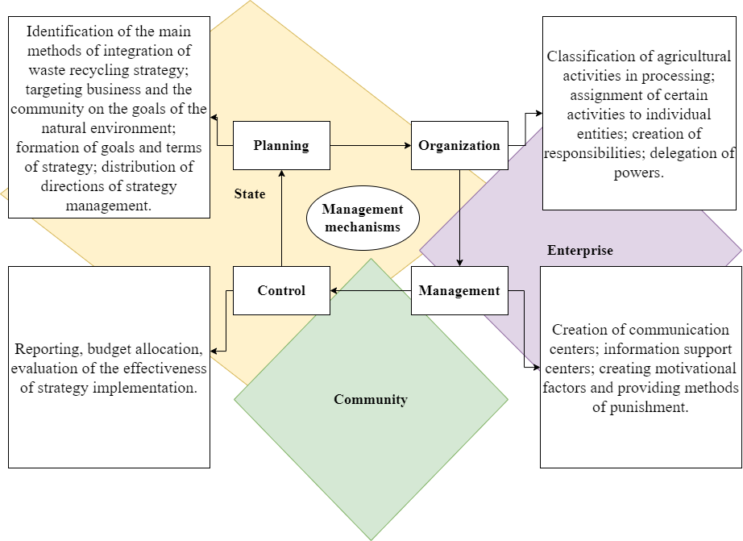  
Fig. 1. Macro level of waste management mechanisms by the method of the Four Functional Approach

Source: created by the author.

It should be noted that in the Ukrainian reality, communication centers and institutions will need to be established to provide an overall assessment of the strategy implementation, while the planning and management function may be transferred to the Ministry of Environmental Protection and Natural Resources. However, the key functional role, namely sorting and recycling, will be played by the community and enterprises, which also carries an action plan. Although the processing of agricultural waste is a fairly new concept, it carries the key concepts of environmental protection, with changing behavioral factors of the population.

The strategy of agricultural waste management - involves changing the general principles of decision-making in favor of nature conservation, and changing behavior to save the planet for future generations. In his book, Crosan Marie describes strategy as a way for an area to compete and win in the marketplace, in which case conservation over nature increases capacity and economic benefits.

Strategy is a way of thinking that provides a tool for building a business and prescribes the main actions and points to achieve goals [1]. Improving the efficiency of agricultural waste management is an important issue for a sustainable economy, urbanization and understanding of the growth of waste-free production and processing, in general in Ukraine. For example, it can solve the problems of such a region as Lviv region, which does not have a large mass of garbage but the problem with its management, and Dnipropetrovsk, Poltava and Kirovograd regions where the share of garbage in Ukraine is the largest garbage in Ukraine [5].

According to Crosan Mary, the scheme of strategic analysis of support mechanisms should consist of such key factors as vision, mission and value. Thus, joining the theory of strategy creation through the path "vision - mission - value" to the system of integration of agricultural waste recycling describes the general theoretical path of the main aspects of the integration of agricultural waste recycling into people's lives (Fig. 2) [1].

In developed countries, the vision of nature protection and combating climate change has long been involved, and strategies for waste management have been developed not only at the macro level, but also at the micro level. Thus, the Plan-Do-Check-Act method, also known as the PDCA method and developed in the 1950s by William, can be used to analyze the micro-level, namely community and business involvement. Edwards Deming [3]. In its structure it is similar to the Four Functional Approach, but has some differences.  
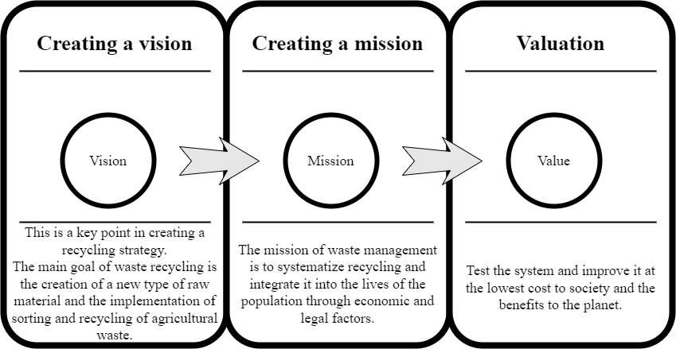

Fig.2. The way of integration and creation of the main aspects of the strategy of agricultural waste recycling.

Source: created by the author

In the modern system of industrial waste management, the first stage plays a significant role, which of the two analyzes we see relies on the state, and the beginning of which in Ukraine can be considered writing and approving the National Strategy for Waste Management in Ukraine until 2030. In the future, the generation and recycling of agricultural waste is entirely in the public and private sectors, in which we can identify three main problems at present, namely:

* non-compliance with the legislation disclosed in the first section, which includes a low level of control over the accounting of waste generation;
* low level of information security of enterprises and the community in the methods of sorting and processing;
* low institutional and structural security of communities and enterprises, in general it is not possible to create waste recycling points at the micro level, and point sorting points do not have the opportunity to transfer waste to a further recycling point.

In his theory, the author describes that strategic goals are an assessment of effectiveness and a description of the timeframe for achieving a strategy. Therefore, each strategy should consist of goals that will lead the strategy to effective results and implementation.

Goals are the main list of objective factors that can be divided into soft and hard goals. In essence, soft goals are goals that may not be strongly adhered to in order to achieve the goals, as their full implementation cannot ensure the full achievement of the strategy's goals. Instead, firm goals are goals of the strategy that must be implemented and implemented primarily to ensure the success of the strategy [1].

The vision of waste recycling envisages the creation of a system of sorting, transportation and recycling of waste with innovative approaches, and reduce excessive negative impact on society. Based on the analysis of the waste recycling strategy, it turns out that the mission of agricultural waste recycling is to minimize the generation and disposal of waste in order to preserve the current ecological status of the environment..

Thus, based on the vision and mission of agricultural waste management, we decided to describe the possible goals of implementing an effective strategy for agricultural waste management according to the method of Mary Crosan, which are described in detail in Table 1. Among these goals are divided into hard and soft factors.

From Table 1. we can see that the solid goals of the agricultural waste recycling strategy include: environmental benefits, the establishment of a recycling control institution, the technical support of waste recycling, the creation of infrastructure, profitability and legal support. It is the implementation of these goals of the strategy of agricultural waste recycling that will ensure the sustainable development of agro-waste recycling. Instead, the implementation of soft targets will increase the success of the implementation of strategies and mechanisms for managing the processing of agricultural waste. It is determined that soft factors help in the implementation of processing in public life, but can not ensure the overall implementation of a sustainable strategy.  
**Table 1. Description of the main objectives of the implementation of product management and their division into soft and hard**

|  |  |
| --- | --- |
| **Hard strategy goals** | **Soft strategy goals** |
| Legal support:   * legislative base of waste processing; * scheme of control over the correctness of waste certification; * fines and penalties for waste disposal or non-sorting of waste; * levers of influence of state authorities on waste recycling. | Business involvement:   * grants for the creation of recycling systems on the basis of the enterprise that generates waste; * benefits for companies that use raw materials from recycled waste; * lending and financing of the business that builds processing plants; * business interest in reducing production waste. |
| Income:   * income from waste processing; * added value to products made from processed goods. | Employees:   * recruitment and recruitment of new supervisors. |
| Infrastructure creation:   * creation of a single garbage sorting system; * construction of innovative hubs for sorting and storing garbage; * construction of key processing plants in all regions. | Sustainable waste system:   * implementation of sustainable development in the processing cycle; * creation of a cyclic processing; * creation of waste-free production; * cyclic production with the inclusion of waste processing. |
| Technical support of waste recycling:   * electronic register of waste; * automatic accrual of waste, depending on the amount of production at the enterprise. | Attracting investors:   * attracting foreign investors to build processing plants. |
| Establishment of a recycling control institution:   * minimum waste limits; * control of garbage removal from production every time; * general inspection of enterprises. | Social factor:   * training and community involvement in recycling; * dissemination of advertising processing and sorting; * main benefits through innovation. |
| Environmental benefits:   * nature conservation factor; * reducing the use of primary raw materials; * reducing the load of landfills. | Innovations:   * introduction of new technologies in processing; * upgrading of recycling systems. |

Source: created by the author.

**Conclusions.** Agricultural waste management is a relatively new phenomenon, which carries a variety of definitions. According to the authors, it is a set of activities of the state, enterprises and citizens, which aims to minimize the harmful effects on the environment without radically reducing production capacity, minimize the remnants of garbage from agricultural production and reduce the harmful effects on the environment.

The socio-economic component is particularly difficult to implement waste recycling, as it is necessary to change the patterns of society's habits in order to fully implement waste recycling. Also, the strength of the level of income of the population is quite significant.

Leading experts described the main points of the strategy and their description, which includes the mission, vision and price / evaluation. This approach is popular in Western literature, while in Ukrainian literature and practice another way is used, namely valuable, vision and only then setting the mission.

The mechanisms of waste management include planning, organization, control and management. The description of waste management mechanisms in the form of three main economic entities, such as the state, enterprise and community, showed that most mechanisms are related to the state and cannot be implemented without its knowledge.

**Список використаних джерел:**

1. Кросан М. М., Русе М. Ж.. Стратегський аналіз і дії. 2011. Вип. 9. С. 54-186.
2. Банбері К., Станерок Р., Субраманян С. Стабільне споживання: самоаналіз багатьох культур. *Журнал бізнес-досліджень*. 2012. С. 497–503.
3. Інструменти розуму. *PDCA (Plan Do Check Act).* *Постійно вдосконалюючись методичним способом.* 2021. URL: https://www.mindtools.com/pages/article/newPPM_89.htm (дата звернення: 24.12.2021).
4. Хант Д. М., Редфорд С. К., Еванс К. Р. Індивідуальні відмінності споживчої вартості для масової продукції на замовлення. *Журнал поведінки споживачів*. 2013. С. 327-336.
5. Рубрика. *Де в Україні найбільше сміття: рейтинг областей за кількістю відходів.* 2020. URL: <https://rubryka.com/infographics/top-regiony-smittya/> (дата звернення: 23.12.2021).
6. Чотири функції менеджменту. *Американський міжконтинентальний університет*. 2018. URL: aiuniv.edu/degrees/business/articles/functions-of-management#:~:text=Originally%20identified%20by%20Henri%20Fayol,organizing%2C%20leading%2C%20and%ccontrolling (дата звернення: 01.12.2021).

**References:**

1. Crossan M. M., Rouse M. J.,(2011). *Strategic Analysis and Action.* Vol 9. pp. 54-186.
2. Banbury, C., Stinerock, R., & Subrahmanyan, S. (2012). Sustainable consumption: Introspecting across multiple lived cultures. Journal of Business Research, 65, 497–503.
3. Hunt D. M., Radford S. K., Evans K. R. (2013). Individual differences in consumer value for mass customized products. Journal of Consumer Behaviour. pp. 327-336.
4. Mind Tools, (2021). PDCA (Plan Do Check Act). Continually Improving, in a Methodical Way. Available at: <https://www.mindtools.com/pages/article/newPPM_89.htm> (Accessed 24.12.2021).
5. Rubrika, [Heading] (2020). De v Ukraїnі najbіl'she smіttya: rejting oblastej za kіl'kіstyu vіdhodіv [Where in Ukraine is the most garbage: the ranking of regions by the amount of waste.] [online] Available at: https://rubryka.com/infographics/top-regiony-smittya/ (Accessed 24.12.2021).
6. The Four Functions of Management (2018). What Managers Need to Know. *American Inter Continental University.* [online] Available at: aiuniv.edu/degrees/business/articles/functions-of-management#:~:text=Originally%20identified%20by%20Henri%20Fayol,organizing%2C%20leading%2C%20and%20controlling (Accessed 01.12.2021).